**Configure and Connect a MySQL Database Instance with a Web Server**

1. Instance Name :- webserver2july23

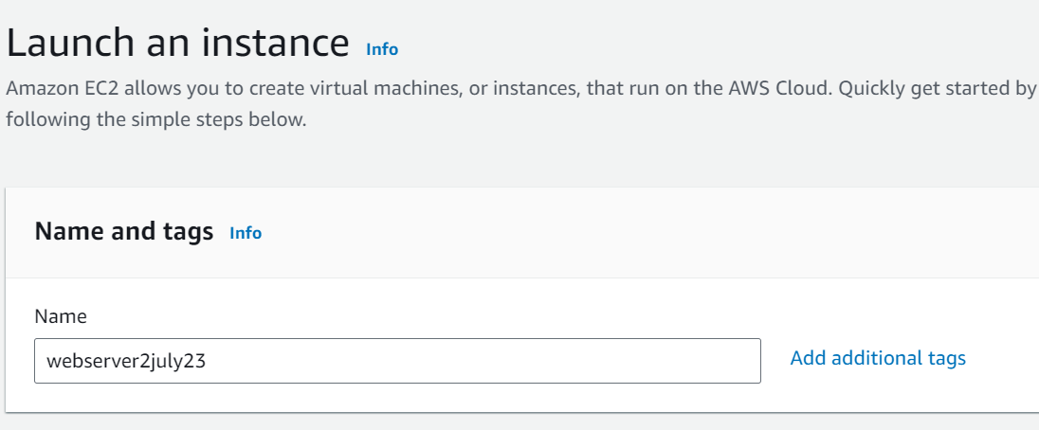

1. Amazon Machine Image :- Amazon Linux 2 AMI (HVM) – Kernel 5.10, SSD Volume Type :-

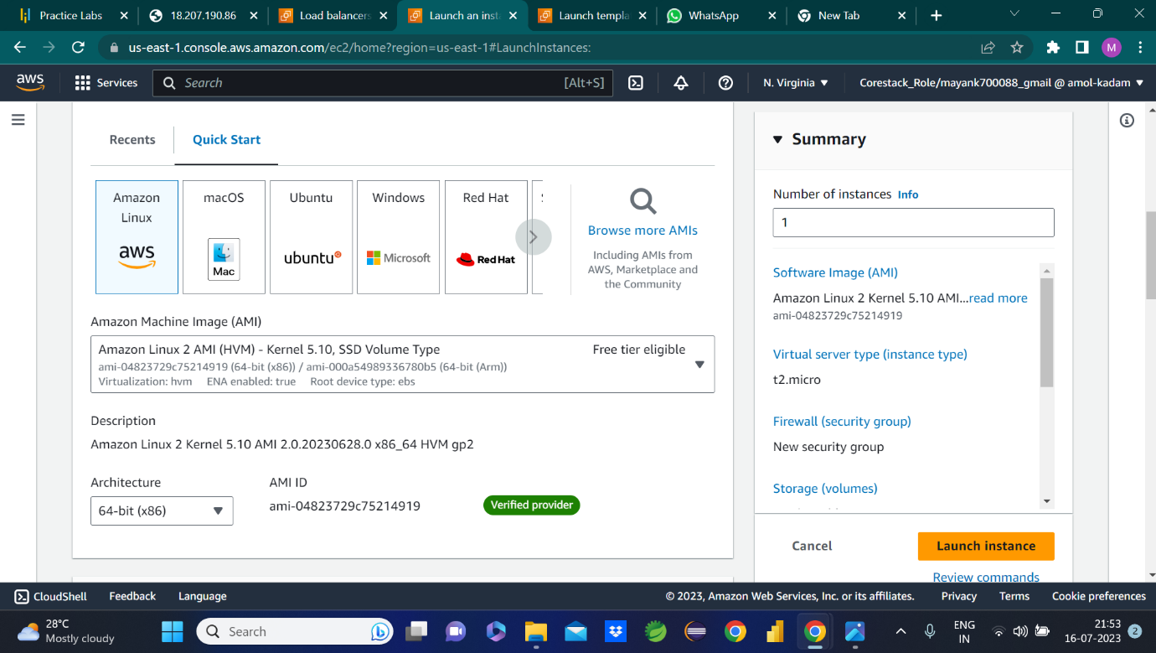

1. Key Pair (Login) :- Key Pair Name – kp2july23

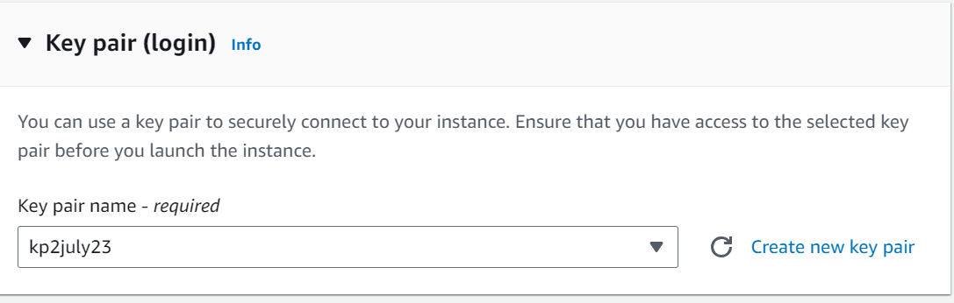

1. Firewall Security Groups :- Allow SSH, Allow HTTPS Traffic, Allow HTTP traffic :-

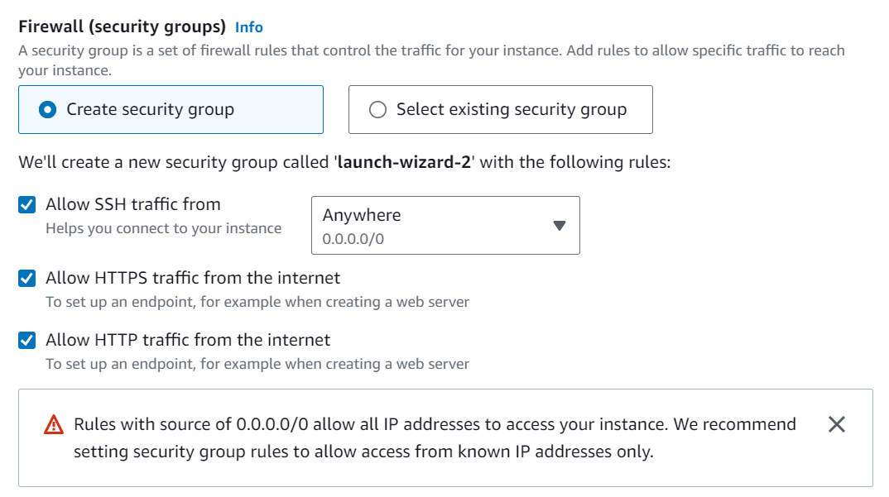

1. Start Script :-

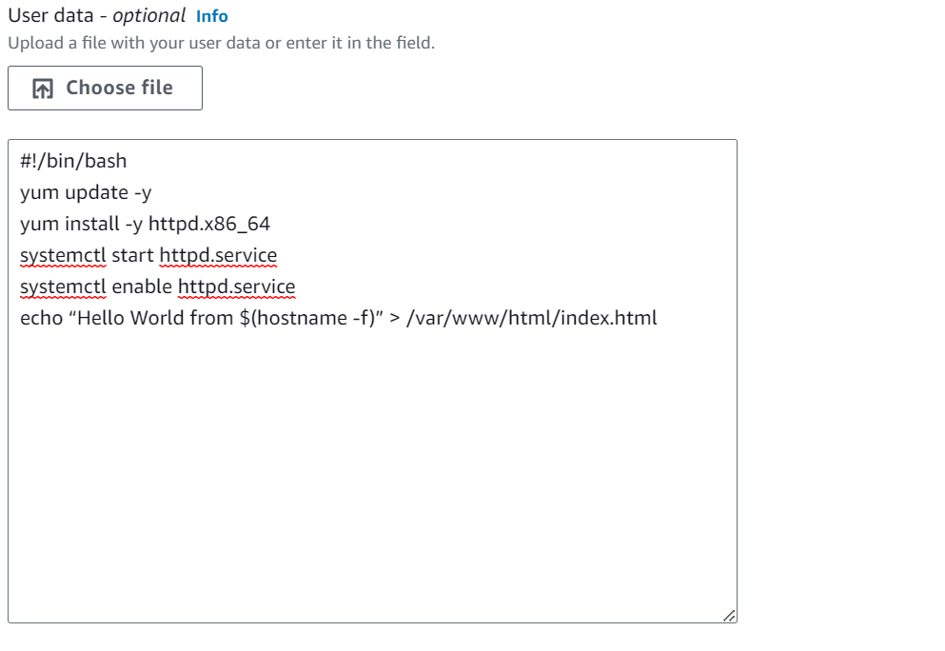

1. Instance Created :- i-0da0a23975c2984e7

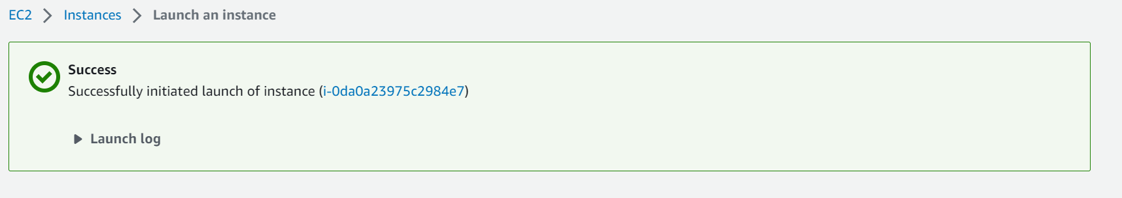

1. Instance in Running State :-

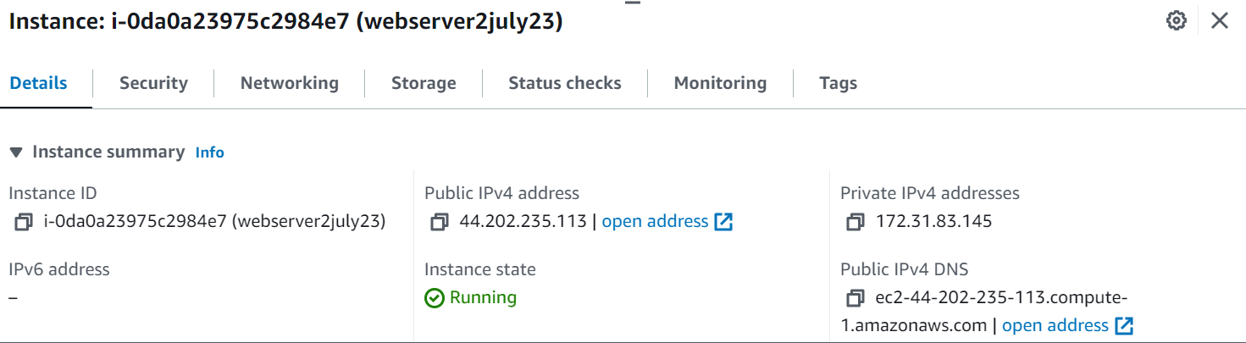

1. IP :- http://44.202.235.113/

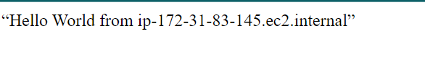

Note :- IAM setup

1. For this project, for any user who is the working user, the IAM user(group of users) will be created with the appropriate policies.
2. Appropriate roles will be created and attached to the services as and when needed.

Note :- Load balancer setup

1. The Application Load balancer will be set up for the webserver (s) for optimized traffic distribution.

Note: Autoscaling Groups

Note: Default VPC

Al resources of this project are launched in the default VPC and the subnet of the default VPC (us-east1c)

**launching RDS on AWS RDS service (MySQL RDS instance)**

1. Create database :- Standard Database

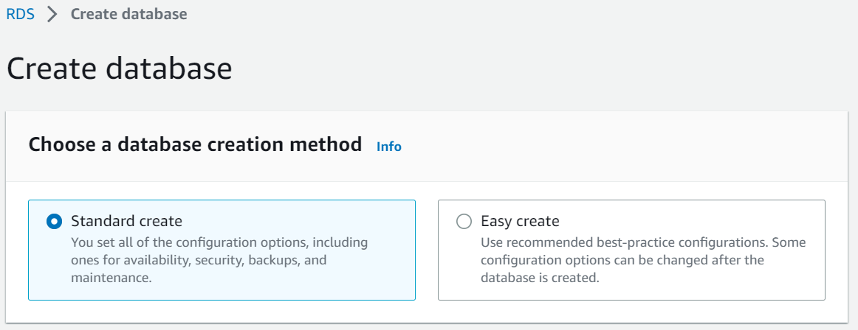

1. Engine :- MySQL

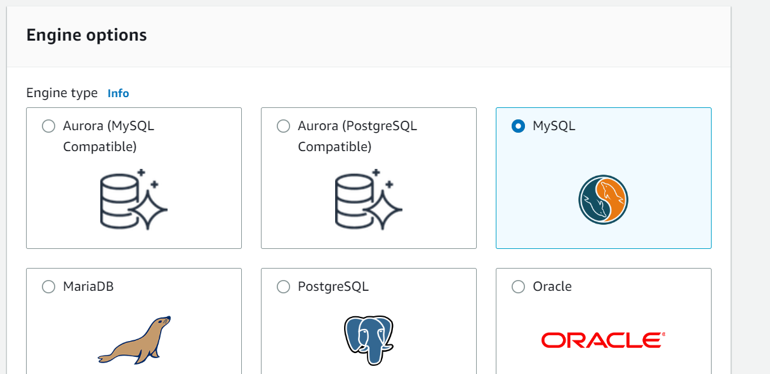

1. Templates :- Free Tier

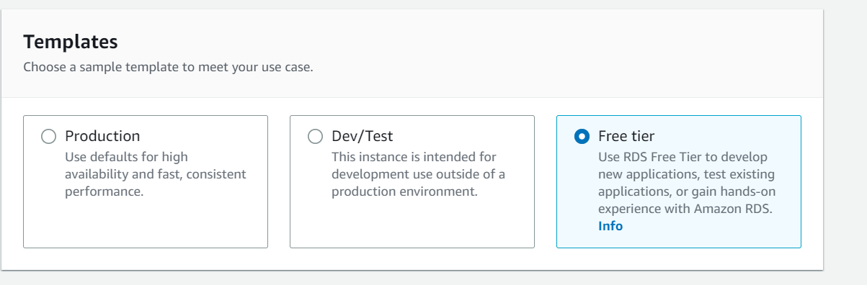

1. Engine Version :- MySQL 8.0.33

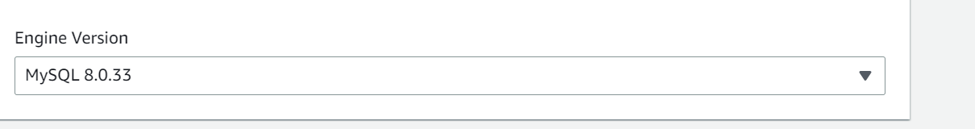

1. Settings :- DB Instance identifier (admin) , Master username (admin)

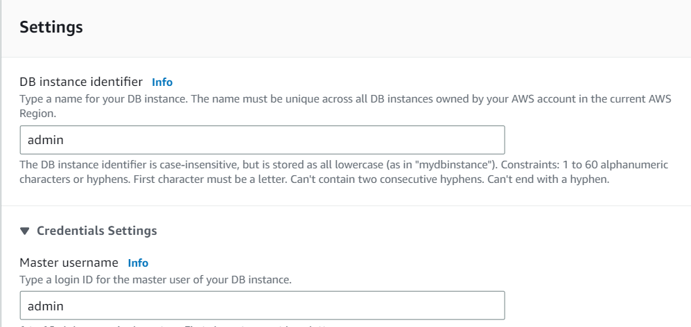

Password :-

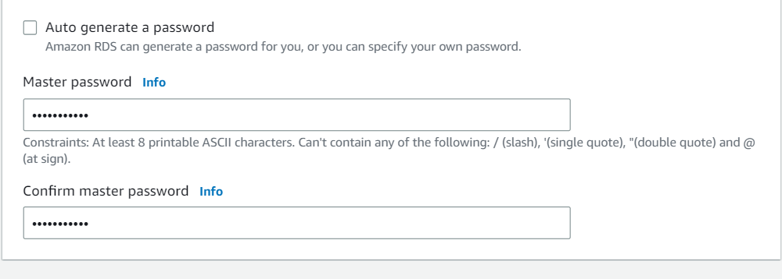

1. Instance configuration :-

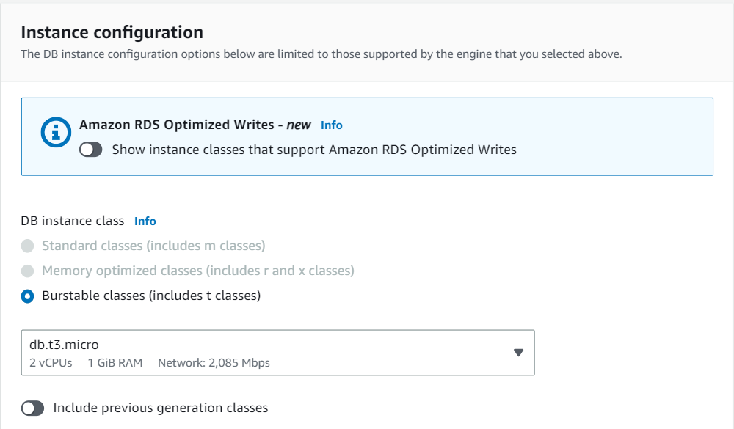

1. Storage :-

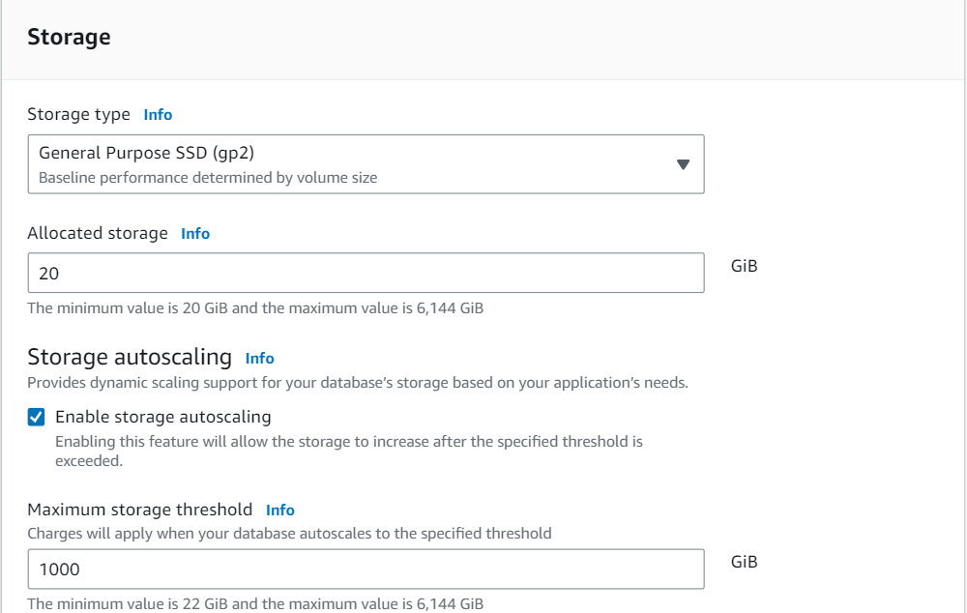

1. Connectivity :-

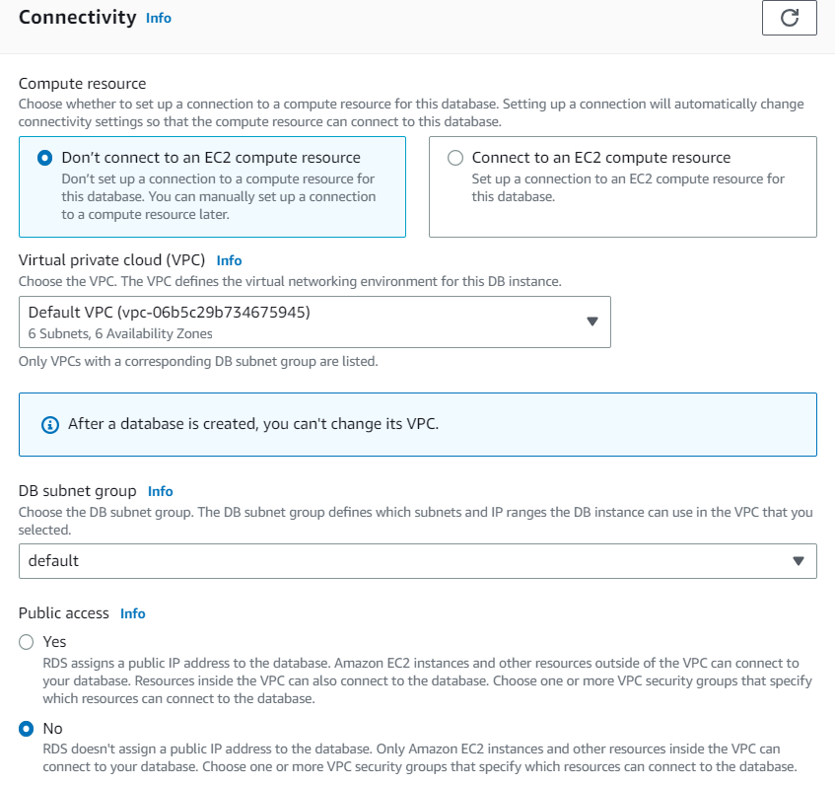

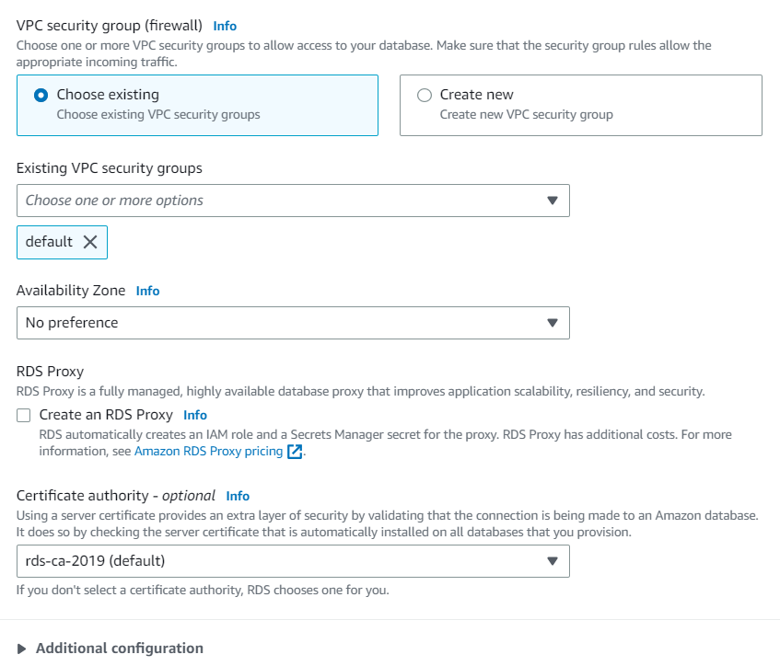

1. Database authentication :-

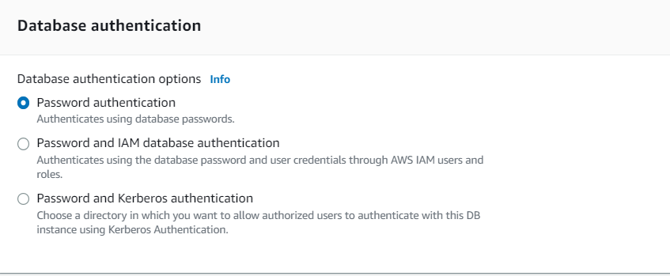

**Webserver and RDS connection**

1. Security Group :- Screenshot of the security grp of RDS instance.

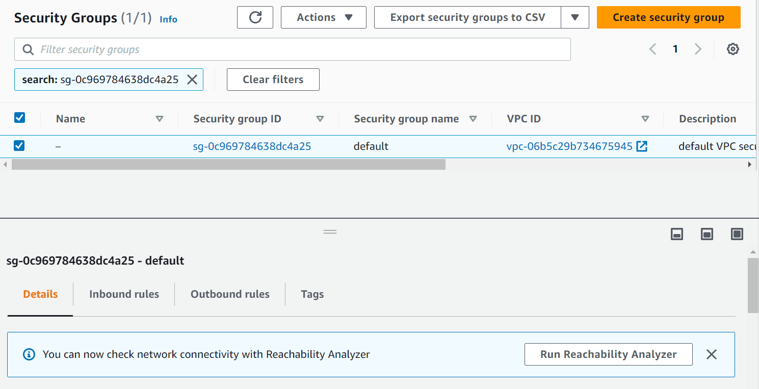

1. Edit the rules of the security group of the RDS instance and add the VM/webserver security group.

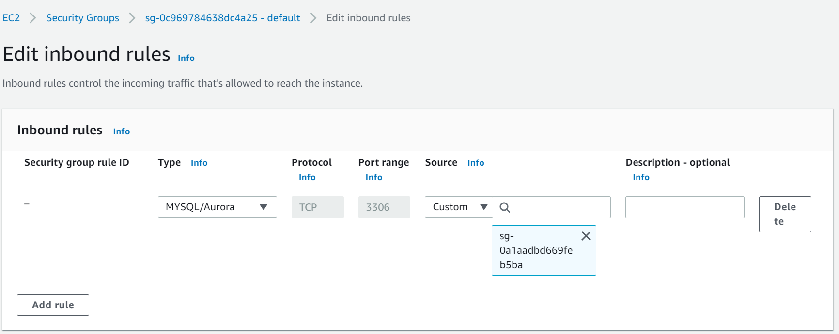

1. Use the below commands to make the final connection :-

Sudo su

yum install mysql

mysql -h admin.czbwlibruzl5.us-east-1.rds.amazonaws.com -P 3306 -u admin -p

username and password

MySQL connected